How to Complete CITI Training for Human Subjects Research
- You must first register at citiprogram.org under an Organization Affiliation with “Department of Energy”.
  - If you already have a CITI profile from a previous organization, select “add an affiliation” on the My Courses Homepage and affiliate with “Department of Energy”.
  - Make sure to affiliate with LBNL as the DOE site if you are an external collaborator!
- The Select Curriculum page should open once you are registered with the institution. On the first page of categories, check the box for Human Subjects Research.
- *Note* If this page does not come up immediately upon registering, or if you need to return to it later, you can select "Add a Course" within the Learner Tools at the bottom of the My Courses Homepage.
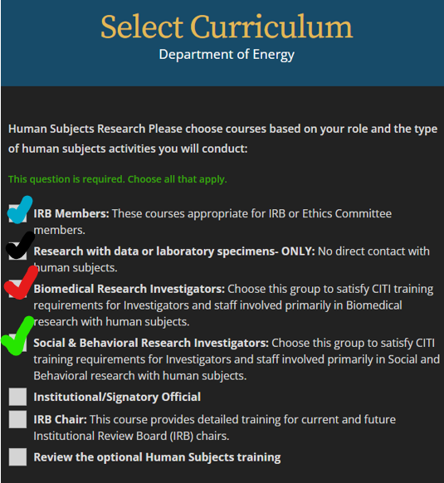
- On the following page, select the course that is most applicable to your research activities.
  - IRB Members – a basic course required for both voting and alternate members of the Human Subjects Committee, and recommended for non-voting SMEs
  - Research with data or laboratory specimens – ONLY: Only satisfies the requirement for projects and/or roles that DO NOT include direct contact with participants.
  - Biomedical Research Investigators- any study that involves working with subjects in a medical setting, including collection of biospecimes, imaging, and administration of drugs.
  - Social & Behavioral - any non-medical intervention or interaction study such as surveys, in-home monitoring of the environment, interviews, or focus groups.
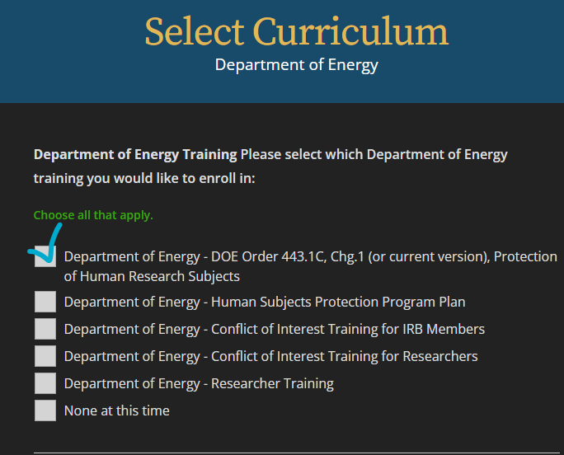
- The Dept of Energy Trainings are required for all investigators submitting to the DOE Central IRB. If you are working only with the LBNL IRB, you need only select the 1st option for DOE Order 443.1C.chg1
- All additional trainings are optional, and can be added for your own education at any time. The HSC reserves the right to require additional training modules or webinars for particular kinds of research or as a part of a Corrective Action Plan, as needed.
  - Responsible Conduct of Research (RCR) training is a requirement only when NIH funding is being used, and can be added through the corresponding selection on the 1st Select Curriculum page.
- Once the required modules have been completed, the proof of completion can be downloaded by selecting the View-Print-Share Record button under the Completed Course.
- Completion Certificates or Completion Reports should be sent to HARC staff (HARC@lbl.gov) for upload to your HARP researcher profile, or uploaded in the HARP Account Request form if you are new to Human Subjects work at the Lab.
  - **NOTE** Collaborating sites with their own FWA are no longer required to have training information added directly to the HARP system, however the lead individual at the responsible institution must be able to provide up-to-date training records upon request.

